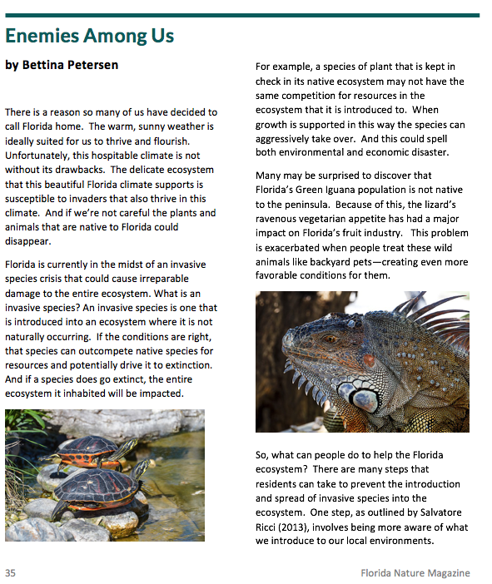

Article title

Author’s name

Page number

**36**